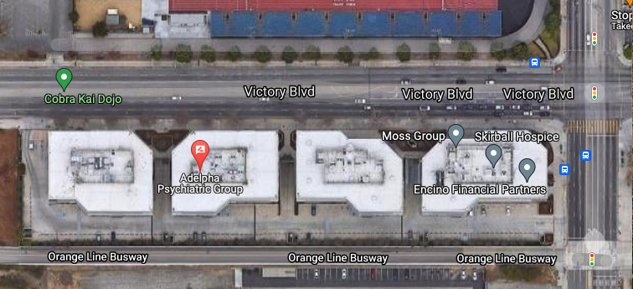

Directions:
Our Balboa office address is 6345 Balboa Blvd., Suite 365, Encino, CA 91316. We are located in building 3 (see photo above with red marker) on the 3rd floor to the right from the elevator. Building 3 is the second closest office building near the Victory Blvd parking lot entrance.

Parking:
Parking is available anywhere along the southside of the complex. The cost for parking is $1.25 per 20 minutes with a maximum of $12.50. Cash and credit card are accepted. To pay for parking, you must exit on the Victory Blvd parking entrance side only.

